**UNCOVERING THE GAMING INDUSTRY HIDEN GAME.A COMPHERSIVE ANALYSIS VIDEO GAMES SALES.**

**Team Leader :**

**A.BLESSY**

**Team Members :**

1. **A.BAVATHARANI**
2. **S.ARCHANAPRIYA**
3. **M.DHARSHINI**

1. **INTRODUCTION**
   1. OVERVIEW

Video games sales analysis is the process of collecting and analyzing data about the sales of video games in order to understand market trends. The whole process of applying user behaviour data to guide sales marketing product enhancement and business decision for any gaming company.

* 1. PURPOSE

The video game industry encompasses the development , marketing and monetization of video games.

1. **PROBLEM DEFINITION AND DESIGN THINKING:**
   1. EMPHATY MAP
   2. 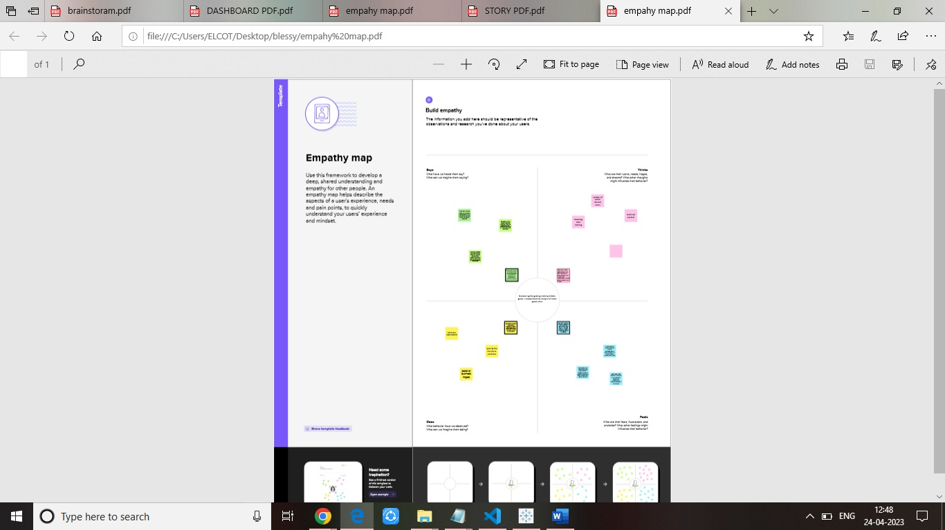
2. **RESULT**
3. 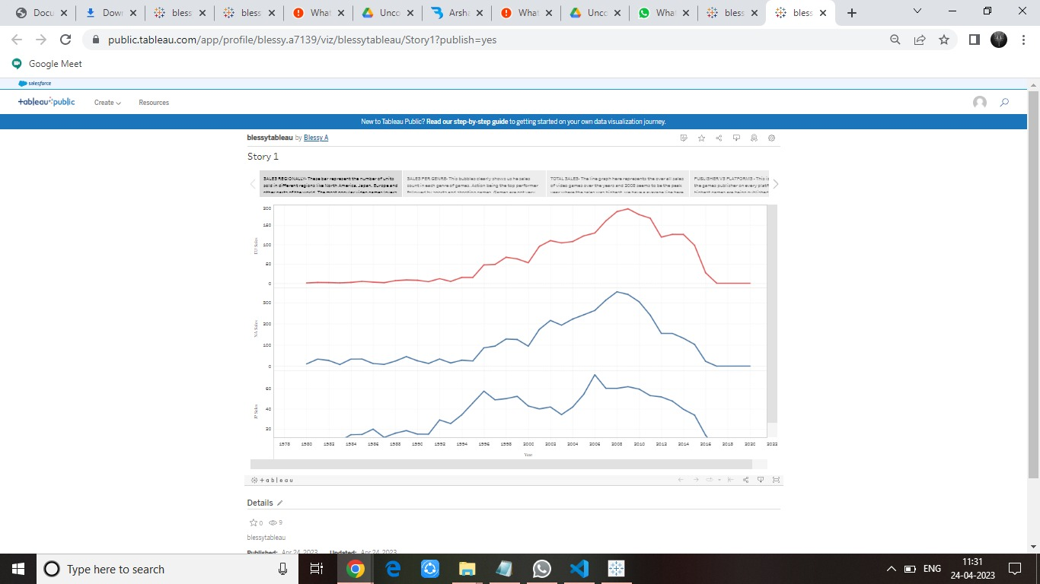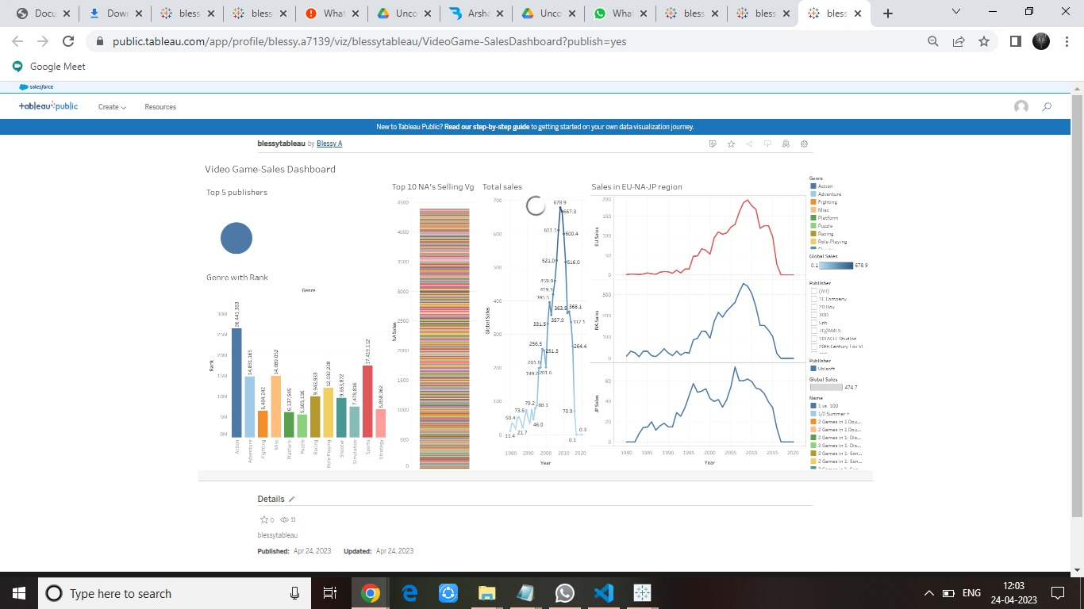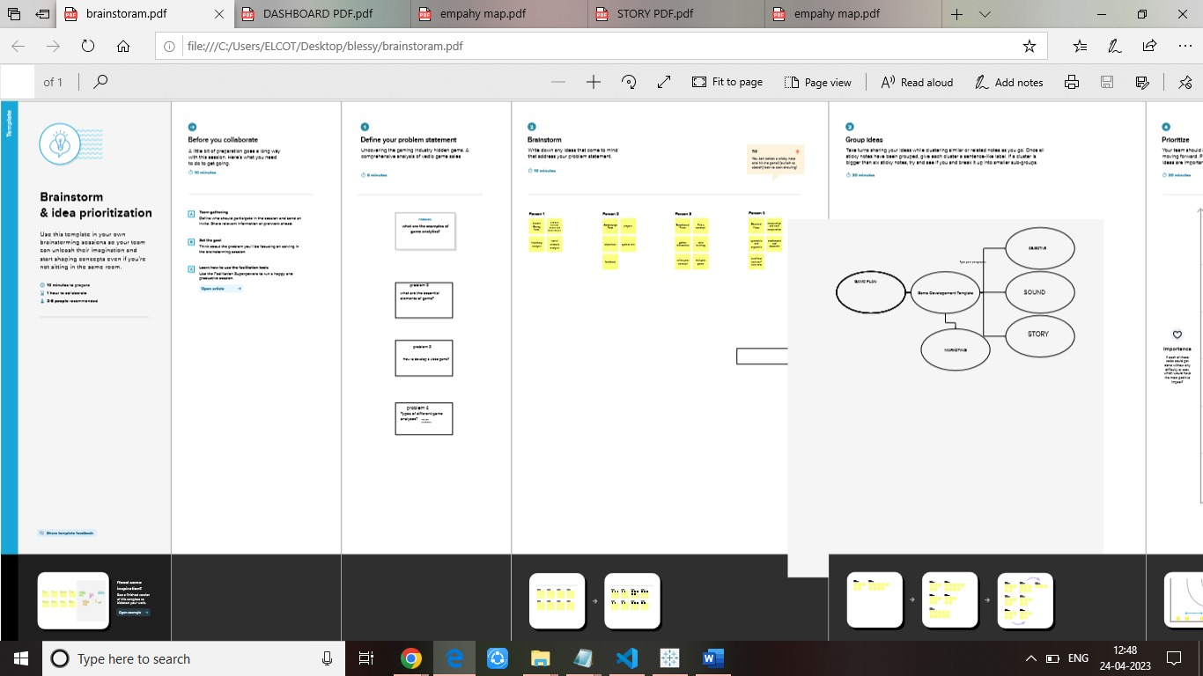
4. **ADVANTAGES AND DISADVANTAGES**
   1. ADVANTAGE

* They speed up response time.
* They encourage teamwork.
* They improve strategy and leadership.
* Critical thinking
  1. DISADVANTAGES
* Sleep deprivation
* Depression
* Aggression
* Anxiety

1. **APPLICATIONS.**

* Video games can improve manual dexterity
* Games may have better social skills
* Games can teach you to be a better problem solver.
* Video games can increase your brain’s gray matter

1. **CONCLUSION**

The video game industry encompasses the development marketing and monetization of video games.

1. **SCOPE**

There is a very wide and bright in future in game design in India. Students can earn up to 3 lakhs to 5 lakhsPA.